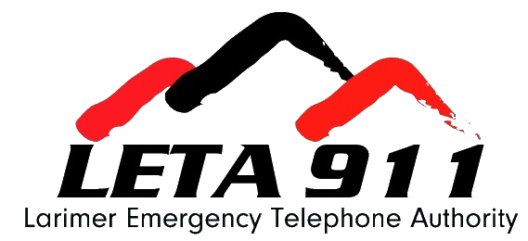

Quality Assurance (QA) Analyst Job Description

Department: Emergency Medical / Operations
FLSA Status: Non-Exempt

Pay Range: $36.54 - $54.80

Revised: May 2026

Position Purpose
Through case review, the QA Analyst will listen critically, identify opportunities, and help elevate emergency medical call handling across the Public Safety Answering Points (PSAPs) within Larimer and Jackson Counties.

This position requires solid working knowledge of Emergency Medical Dispatch (EMD) through the International Academies of Emergency Dispatch (IAED). Employees must exercise some independent judgement in the performance of their duties and handle moderately complex issues and problems.

Duties and Responsibilities

- Conduct case reviews of calls for each PSAP to monitor compliance with the medical protocol performance standards.
- Create weekly EMD reports highlighting PSAP compliance and trends.
- Participates in calibration cases to ensure consistency throughout the QA team at LETA.
- Attend countywide EMD meetings, as assigned, to share and acquire information on medical training needs and effectiveness.
- Attend PSAP meetings to discuss protocol questions and concerns and plan training topics.
- Create CDEs and training opportunities for all EMDs.
- Attends and participates in national professional groups, meetings, and conferences to remain current on current trends and information relating to dispatch programs and training.
- Maintain competency in currently used protocol software and tests new software as it becomes available; recommend, implement, and conduct training on software.
- Perform all other related duties as required by management.

Note – Time spent on each essential function will vary based on operational needs and is only intended to be an approximation over the course of a full year. Regular and predictable attendance is an essential function in the performance of this job.

Knowledge, Skills, and Abilities

Knowledge Of:
- Principles and practices of the International Academy of Emergency Dispatch (IAED) medical protocols.
- Creating and maintaining databases and generating reports.
- 911 calltaking policies and procedures for medical calls.
- Federal, State, and local laws, codes, and regulations related to public safety.
- Quality assurance and improvement principles and practices.
- Microsoft Word, Excel, MS Projects, and Outlook.​

Ability To:
- Think critically using logic and reasoning to identify potential solutions, conclusions, or problem approaches.
- Maintain the confidentiality of records and information.
- Establish and maintain effective working relationships with peers, vendors, PSAP employees, partner agencies and LETA staff members.
- Monitor the performance of PSAPs as it relates to medical protocols.​
- Assist in facilitating the coordination of classes, meetings, and programs related to the Emergency Telecommunicator Course (ETC) and Emergency Medical Dispatching (EMD).
- Drive Authority vehicles safely.

People Skills:
- Ability to effectively manage time and perform multiple tasks simultaneously.
- Ability to interact professionally with all staff, stakeholders, and citizens.
- Communicate clearly and concisely, both orally and in writing.

Relevant Education, Experience and Certification Requirements

Education:

One (1) year of coursework from an accredited college or university focusing on education, communication, management, business management, or another related field is required.

Education and Experience Equivalency:
One year of relevant work experience may be substituted for one year of required education.
Experience:
At least 3 years working in a public safety emergency communications center (PSAP) using the current IAED protocol system or a related field.

Certifications and Licenses: Must possess or be able to acquire the following certifications and/or licenses as outlined below:
- Possession of, or ability to obtain, an IAED QA certification in EMD within 3 months of date of hire is required.
- Possession of, or ability to obtain, a nationally recognized Cardiopulmonary Resuscitation (CPR) certification within 3 months of date of hire is required.

All required licenses and certifications must be maintained throughout the term of employment.

Technical Skills:
Intermediate Skills and Knowledge: Work requires proficient skills and knowledge in approaches and systems, which support the design and implementation of major programs and/or processes organization wide. Independent judgment and decision-making abilities are necessary to apply technical skills effectively.

Specialized Computer Equipment and Software:
ProQA, Microsoft Office Suite, AQUA, NICE, Imprivata, Canva and other creative design and educational software.

Additional Information
Supervision Exercised:
This position does not exercise any supervision.

Supervision Received:

This position performs duties under the general supervision of the EMD Program Manager.

Environment and/or Physical Factors:

The work environment, physical and mental characteristics described here represent those an employee encounters while performing the essential functions of this job. Reasonable accommodations may be made to enable individuals with disabilities to perform essential functions.

Locations
- In-person at LETA, 4867 Venture Drive, Johnstown, CO 80534
- No remote work

Disclaimer
The above statements are intended to describe the general nature and level of work performed by employees assigned to this position. It is not designed to contain or be interpreted as a comprehensive list of all duties, responsibilities, and qualifications. The Authority management reserves the right to amend and change responsibilities to meet business and organizational needs, as necessary.

